**Bagadiong, Sharee Mae F.**

**2-ECE-B**

**Hangaroo Game**

**Scenario 1: secret word is guessed correctly**

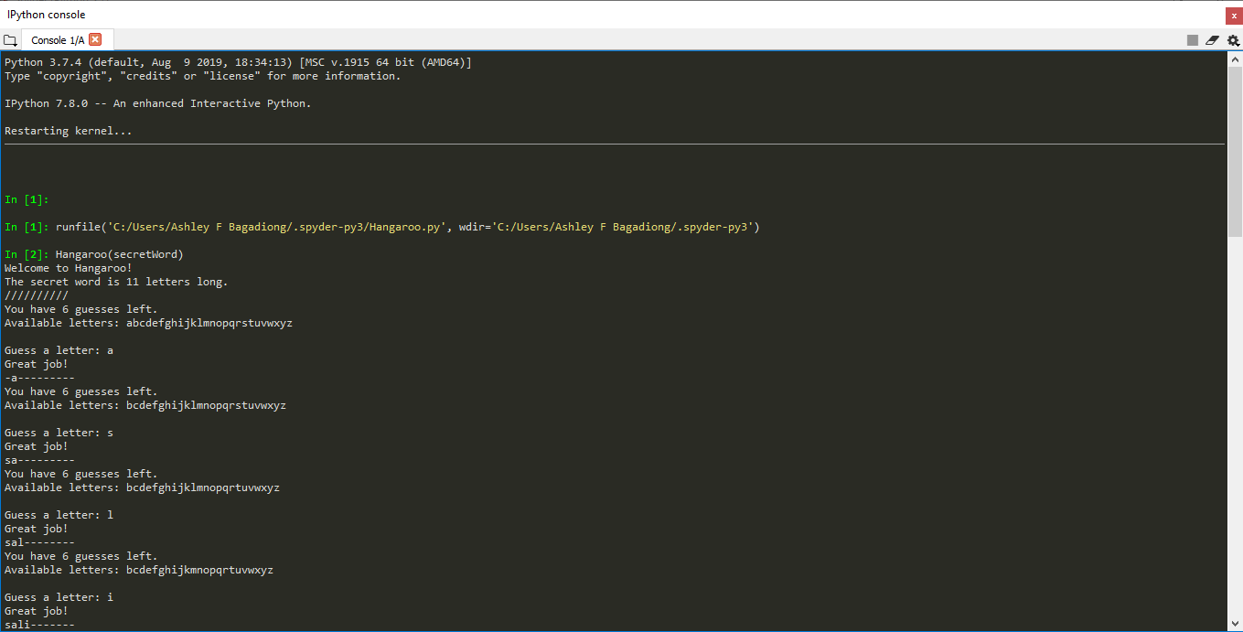

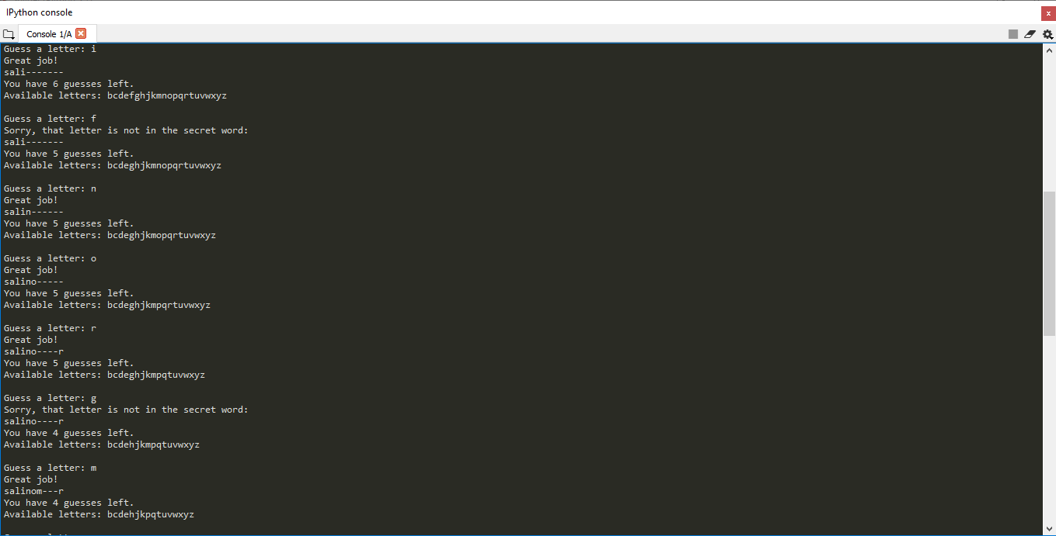

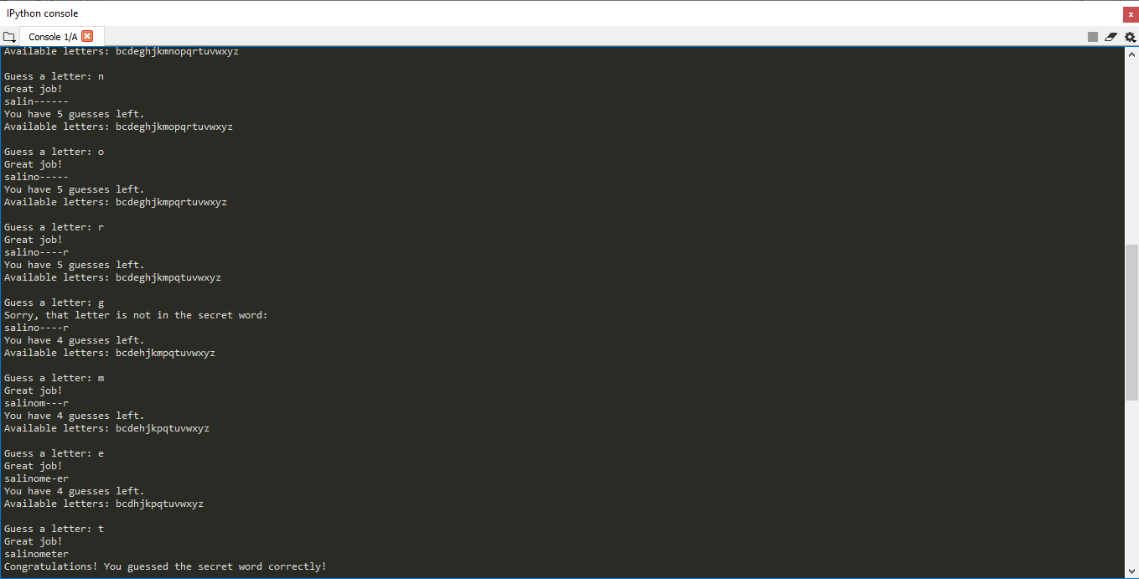

**Scenario 2: failure to guess the secret word**

